Lab - Compromise IoT Device Hardware

1. Topology

1. Raspberry Pi Pinout Diagram

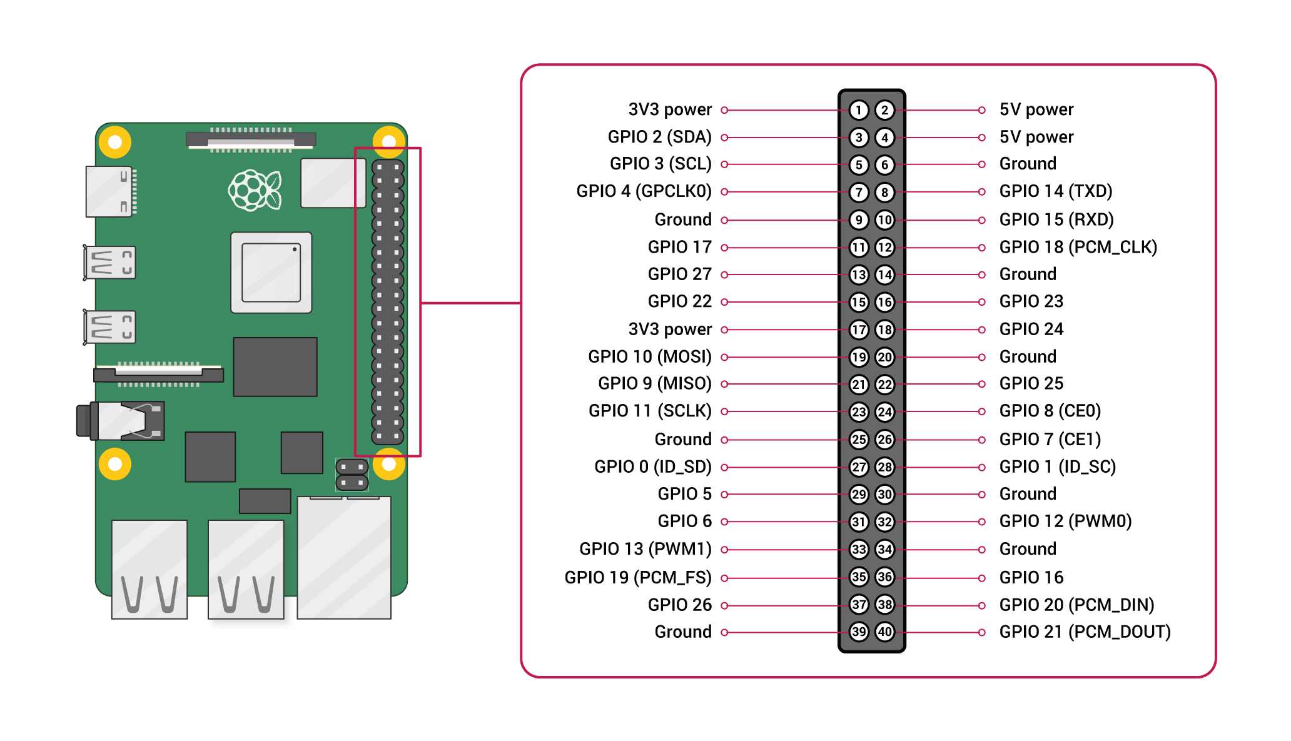

1. Objectives

Perform threat modeling activities to evaluate IoT device hardware and firmware.

Part 1: Accessing the Raspberry Pi with Serial Interface

Part 2: Disabling Serial Login Access to Raspberry Pi

1. Background / Scenario

This lab will demonstrate how an IoT device may be compromised by physically connecting to the device using communication protocols other than Ethernet. A Raspberry Pi could be used for controlling and monitoring many types of equipment. It is important that security is in place at the forefront when configuring and positioning these types of devices. The last part of the lab demonstrates how to secure against these compromises.

The lab makes use of a variant of the RS-232 serial communication standard that has been used since the 1960’s to communicate between various types of equipment.

**Please note the use of a special cable being used to connect the Raspberry Pi to the PC serial port. Even though some PCs still have conventional RS-232 COM ports it is imperative that direct connections from those pins are not made directly to the Raspberry Pi. The Raspberry Pi uses +3.3v for the serial pins whereas the RS-232 specification indicates voltages up to +13v.**

There are other possible methods for reducing the voltage given the header connections on the Raspberry Pi and many other IoT type devices this provides the simplest way to accomplish serial connectivity.

1. Required Resources

* ER-X edgerouter configured as in “Lab 2. ER-X Set Up For Cisco labs.pdf”
* Raspberry Pi 3 Model B or later (with PL-App)
* 8GB Micro SD card (minimum required)
* PC with IoTSec Kali VM and terminal emulation software, such as PuTTY
* Network connectivity between PC and Raspberry Pi
* USB TO TTL SERIAL CABLE

1. Accessing the Raspberry Pi with the Serial Interface

This part of the lab will create a TTY connection to the Raspberry Pi using a USB to Serial Cable connected to the serial pins on the Raspberry Pi header.

* + 1. Set up the topology.
       1. Start the IoT Security lab topology with Kali VM and Raspberry Pi connected physically via an Ethernet cable.
       2. Raspberry Pi has dynamic IP address provided by dhcp service in ER-X. To find out Raspberry Pi’s IP address, either
          1. with CLI, log into ER-X with “ssh ubnt@203.0.113.10” and command “show dhcp leases”
          2. with browser, logging into ER-X at 203.0.113.10 and checking out DHCP leases at tab ”Services” / “Actions” / “View Leases”
          3. Connect display to RasPi and check final boot messages
       3. Open a web browser in the Kali VM or your host PC and navigate to the IP address for your Raspberry Pi.
       4. Using the pinout diagram above or refer to the diagram at <https://pinout.xyz>, locate the Raspberry Pi pins listed in the following table.  
          Table

          Description automatically generated  
          Diagram

          Description automatically generated
       5. After locating the necessary pins, power off the Raspberry Pi until instructed to power it up again.

(pl-app) root@myPi:/home/pi/notebooks# **shutdown -h now**

* + - 1. Unplug the Raspberry Pi from the power source. With the Raspberry Pi turned off, connect the USB to Serial Cable to the pins listed in the above table on Raspberry Pi.
    1. Configure software – Windows (skip this step if using Linux)
       1. Plug in the USB to TTL Serial Cable to a USB port on the PC. The drivers should install automatically.
       2. Navigate to the Device Manager to determine the COM port assigned to the USB to Serial connection. In this example, USB-to-Serial is using COM3.

* + - 1. The following settings will need to be defined for connecting to the Raspberry Pi using the console port.

| Description | Settings |
| --- | --- |
| Port | COM port used as indicated in Device Manager |
| Baud Rate | 115200 |
| Data bits | 8 |
| Stop bits | 1 |
| Parity | None |
| Flow control | None |

For example, in PuTTY session screen, select the **Serial** radio button, input the COM port listed in the Serial line box matches the COM port determined in Device Manager and the correct Baud rate is specified.

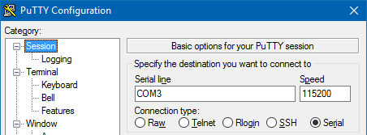

Expand **Connection** and click **Serial** to verify all the options are configured according to the above table. Click **Open** to start the terminal session to the Raspberry Pi. PuTTY is waiting for output from the Raspberry Pi or input from the keyboard.

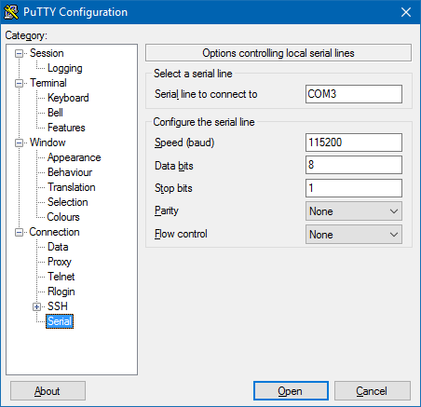

* + - 1. Power up the Raspberry Pi. Output from the Raspberry Pi should start scrolling across the screen as shown below.

[ 0.000000] Booting Linux on physical CPU 0x0

[ 0.000000] Linux version 4.14.30+ (dc4@dc4-XPS13-9333) (gcc version 4.9.3 (crosstool-NG crosstool-ng-1.22.0-88-g8460611)) #1102 Mon Mar 26 16:20:05 BST 2018

[ 0.000000] CPU: ARMv6-compatible processor [410fb767] revision 7 (ARMv7), cr=00c5387d

<Some output omitted>

Welcome to the Chestnut Platform!

Version: 2.1

IP: 203.0.113.11

myPi login:

What version and type of operating system is displayed in the output?

Linux version 4.14.30+

What type of processor is being used?

CPU: ARMv6-compatible processor [410fb767] revision 7 (ARMv7)

* + - 1. Log in using the credential for the user **pi** configured for your Raspberry Pi in a previous lab.
    1. Configure software – Linux (skip this step if using Windows)
       1. On a Linux platform (your host PC) determine the port to use by listing the tty ports in the /dev folder.

user@computer ~ $ ls /dev/ttyUSB*

* + - 1. Assuming the USB tty port is USB0, access the USB to Serial connection by typing the following:

user@computer ~ $ **screen /dev/ttyUSB0 115200**

* + - 1. Power up the Raspberry Pi. Output from the Raspberry Pi should start scrolling across the screen as shown below.

[ 0.000000] Booting Linux on physical CPU 0x0

[ 0.000000] Linux version 4.14.30+ (dc4@dc4-XPS13-9333) (gcc version 4.9.3 (crosstool-NG crosstool-ng-1.22.0-88-g8460611)) #1102 Mon Mar 26 16:20:05 BST 2018

[ 0.000000] CPU: ARMv6-compatible processor [410fb767] revision 7 (ARMv7), cr=00c5387d

<Some output omitted>

Welcome to the Chestnut Platform!

Version: 2.1

IP: 203.0.113.11

myPi login:

What version and type of operating system is displayed in the output?

Skipped this , we are using windows

What type of processor is being used? Skipped this , we are using windows

Login to the Raspberry Pi using the user **pi** and password configured for your Raspberry Pi.

1. Disabling Serial Login Access to Raspberry Pi

If the Raspberry Pi is intended to be collecting sensitive information, and there is any possibility of physical access to the device, it is probably best to disable login access through the serial line.

* + 1. Connect to the Raspberry Pi through the console

It will be necessary to get a console connection to the Pi either through a direct cable connection or through the PL-App console. Login using the credentials for the user **pi** as defined for your particular device.

* + - 1. After the connection is established, modify the Raspberry Pi configuration using the following command:

pi@myPi$ sudo raspi-config

* + - 1. Depending on your Raspberry Pi version, select **Interfacing Options** -> **Serial** and press Enter or select **Advanced Options** -> **Serial** and press **Enter**.
      2. Select <**No**> for the question "Would you like a login shell to be accessible over serial?" and press **Enter**.
      3. Select <**Yes**> for the question "Would you like the serial port hardware to be enable?" and press **Enter**.
      4. On the next screen, verify that the login shell is disabled and serial interface is enabled. Press <**OK**> to continue.
      5. Select <**Finish**> to exit the configuration window.
      6. Reboot the Raspberry Pi when prompted. If not, enter the command **sudo reboot** at the prompt to reboot the Raspberry Pi. Then watch the output in the terminal application window.

$ sudo reboot

* + 1. Attempt to reconnect with the serial connection
       1. After the rebooting process is finished, the Raspberry Pi should no longer display a command prompt in the terminal application. This port may now be used to communicate with other devices for data collection. If there are any connections to the serial port, it is important that they be protected because anyone with the appropriate cable could connect to the device and exfiltrate data.
       2. In the Kali VM or the host PC, navigate to the web page of the terminal window of the PL-App for your Raspberry Pi.
       3. To simulate data being transmitted from the IoT device, create a Python script by pasting the following at the prompt at the terminal of the PL-App.

Enter the command **cat > comout.py** at the prompt.

(pl-app) root@myPi:/home/pi/notebooks# **cat > comout.py**

At the cursor, paste the following script:

#!/usr/bin/env python

import time

import serial

ser = serial.Serial(

port='/dev/serial0',

baudrate = 115200,

parity=serial.PARITY_NONE,

stopbits=serial.STOPBITS_ONE,

bytesize=serial.EIGHTBITS,

timeout=1

)

counter=0

for counter in range(9):

ser.write(b'Write counter: %d \r\n'%(counter))

time.sleep(2)

* + - 1. After pasting the script into the terminal window, press **CTRL-D** to close the file.
      2. Issue the command **python comout.py** at the prompt.

(pl-app) root@myPi:/home/pi/notebooks# python comout.py

* + - 1. Navigate to the terminal application (PuTTY).

Notice how the output can be read on the terminal. The terminal pauses 2 seconds between each time output is written to the screen as instructed in the Python script.

Putty’s output:

1. Reflection
   1. Knowing what you know so far, do you think it would be possible to connect two Raspberry Pi devices together using the serial pins? If so, how?

Yes, it is possible.

To do that with jump wires we have to connect:

* 1. The Tx pin on the Raspberry Pie #1 to the to the Rx pin on the Raspberry Pie #2
  2. The Tx pin on the Raspberry Pie #2 to the to the Rx pin on the Raspberry Pie #1

The serial ports of the **Raspberry pi’s can be disabled for login. The terminal emulation software will set the same baud rate in order to establish communication.**

* 1. What kind of information might you need to know in order to capture the data coming out of the serial port of an IoT device?

To capture the date coming out of the serial port of the IoT device we would need the baud rate (could be determined by try and error) , stop nits, parity and flow control setting on the IoT device.